# GCS (Ground Control Station)

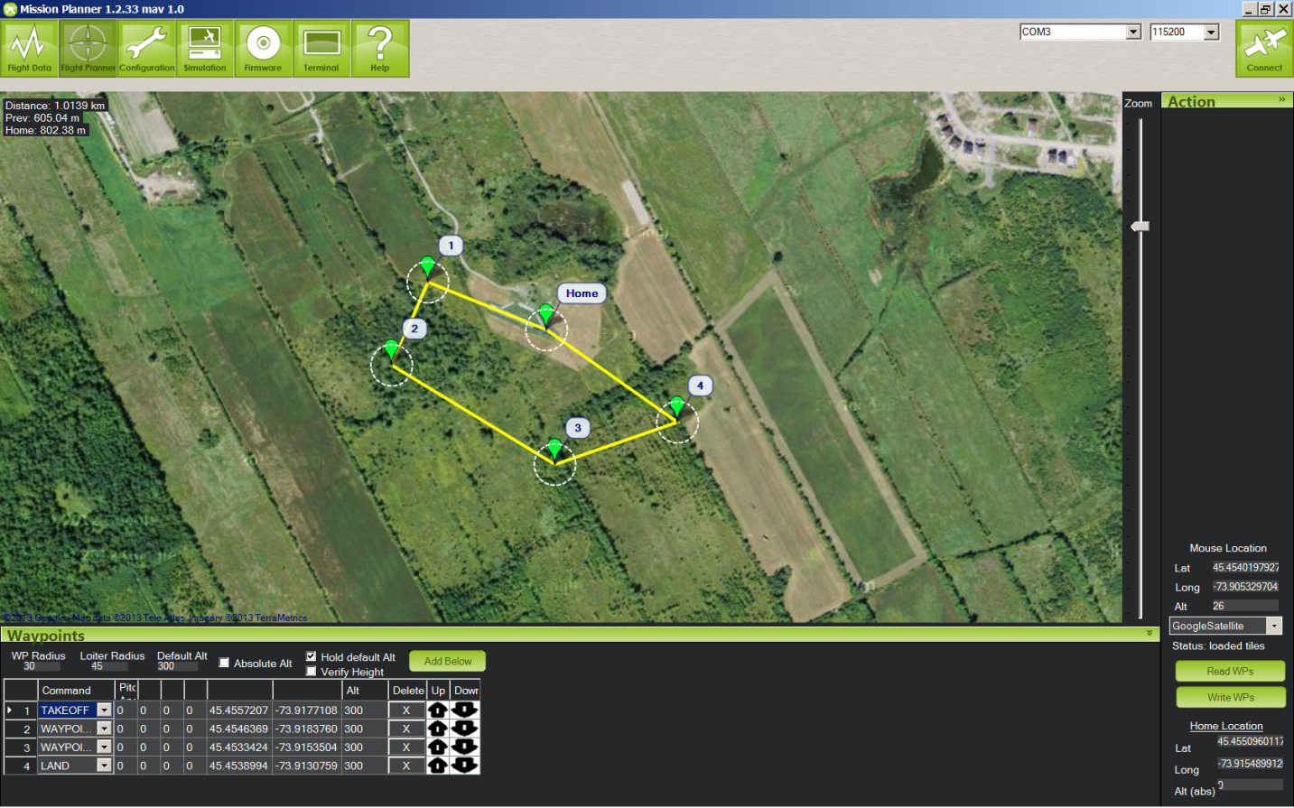

* Accurate Waypoint Navigation (up to 9 meters resolution)
* Easy Simulation Capabilities
* Extensive Telemetry for post flight analysis
* Open-Source Code base for easy hacking and modification

# Ardupilot

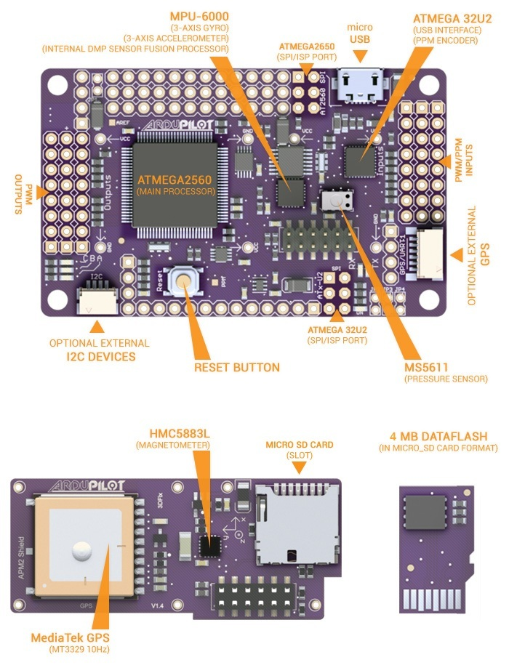

* Well integrated sensor package
* Open-Source Firmware and Development
* Easily extensible for different tasks and
* Tested platform with Six year development history

# FEA (Femap NX Nastran)

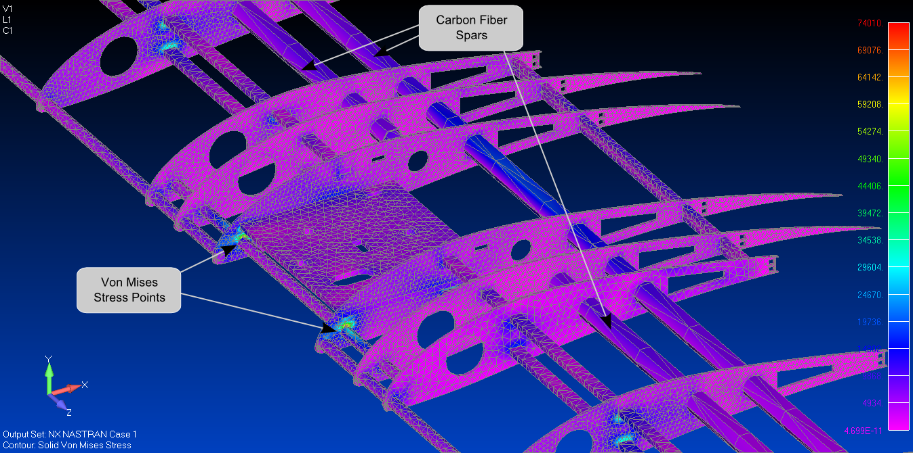

Figure 1: Wing Core FEA for Three Point Bending (10 lbf load)

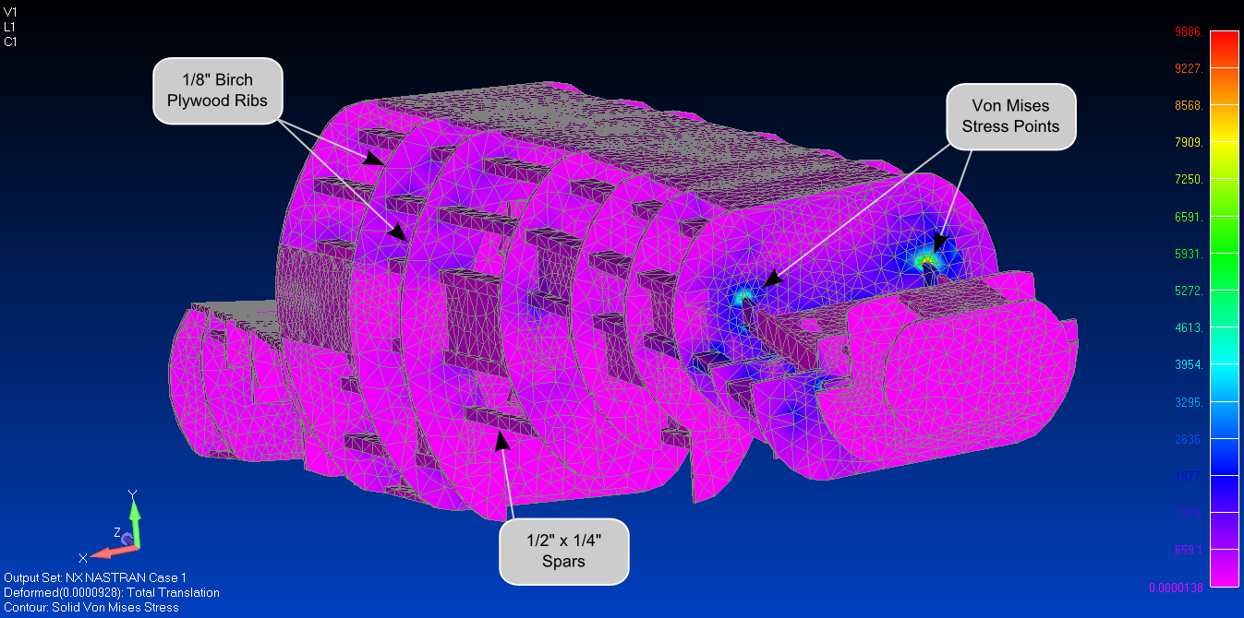

Figure 2: Fuselage FEA Torsion Test (16 ft-lbf)

* Simulation of Wing Torques on the Fuselage led to further reinforcement of the Stress Points
* Simulation of three point bending led to reduction of weight of the wings (Ply -> Balsa)

# CFD (OpenFoam)

